# **CASE STUDY - ONLINE BANKING ANALYSIS**

Submitted By-

Subrat Shukla, DE-1

**Loading Datasets:**

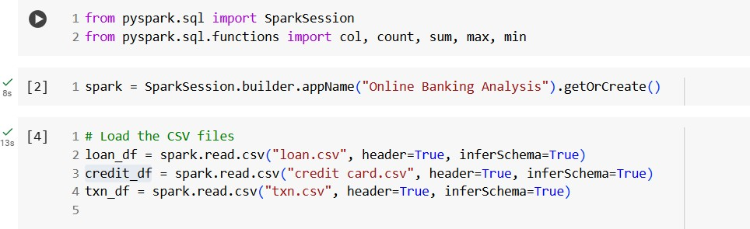

# **In Loan Data CSV file-**

1. 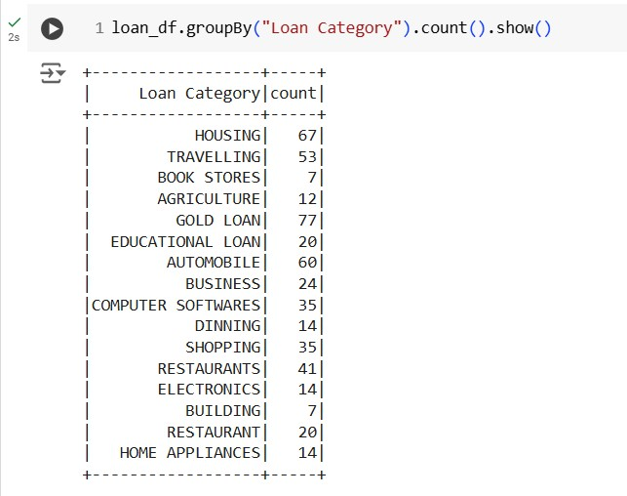**Number of loans in each category**
2. **Number of people who have taken more than 1 lakh loa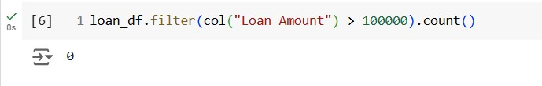n**
3. **Number of people with income greater than 60000 rupees**

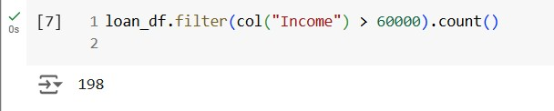

1. 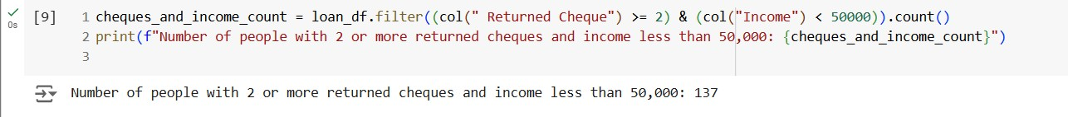**Number of people with 2 or more returned cheques and income less than 50000**
2. **Number of people with 2 or more returned cheques and are single**

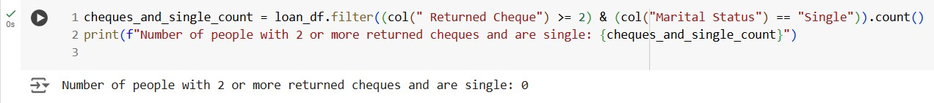

1. **Number of people with expenditure over 50000 a month**

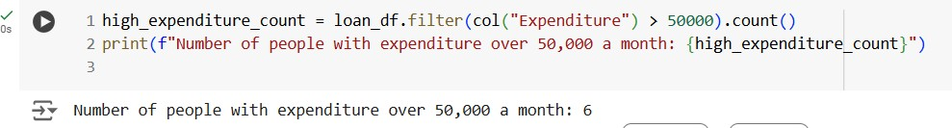

1. **Number of members who are eligible for credit card**

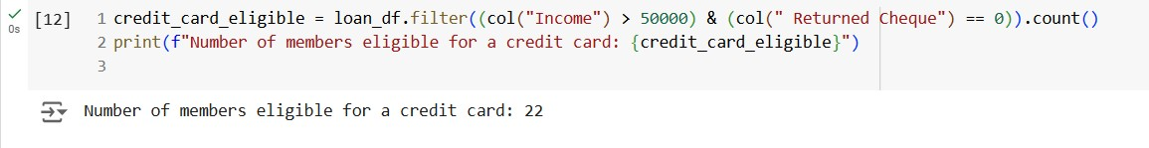

* **In Credit CSV file-**

1. 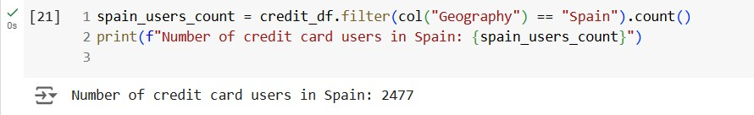**Credit card users in Spain**
2. 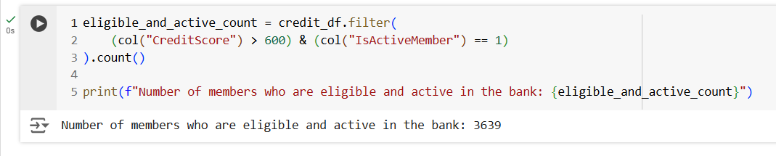**Number of members who are eligible and active in the bank**

# **In Transactions file-**

1. 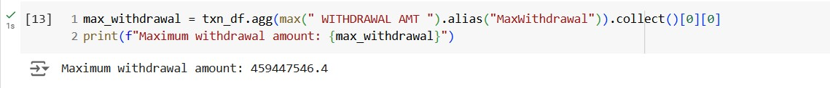**Maximum withdrawal amount in transactions.csv**
2. **Minimum withdrawal amount in transactions.csv**

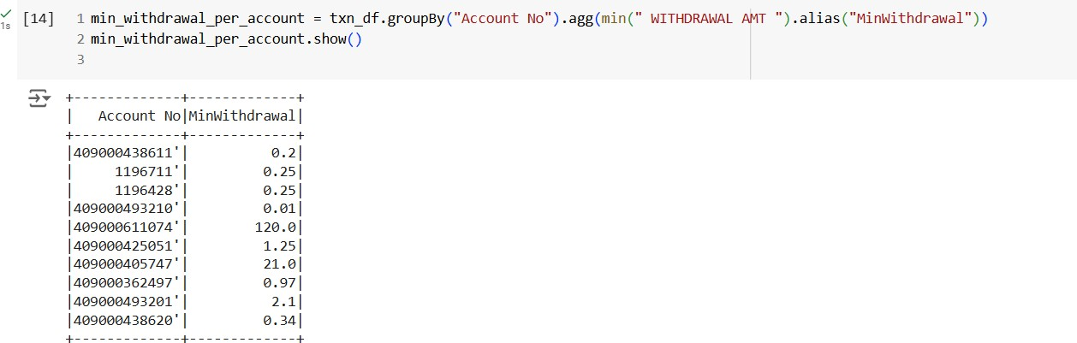

1. 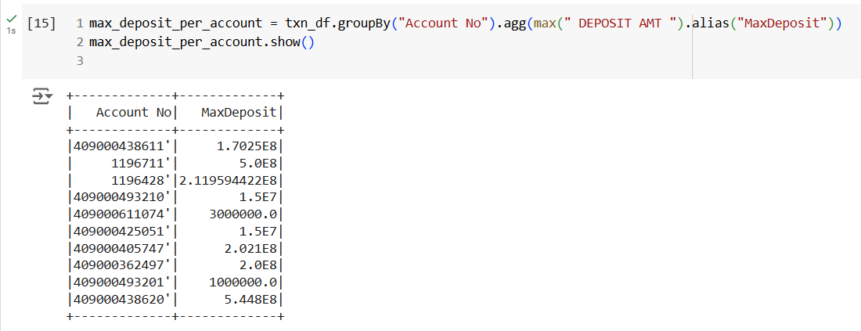**Maximum deposit amount of an account**

1. 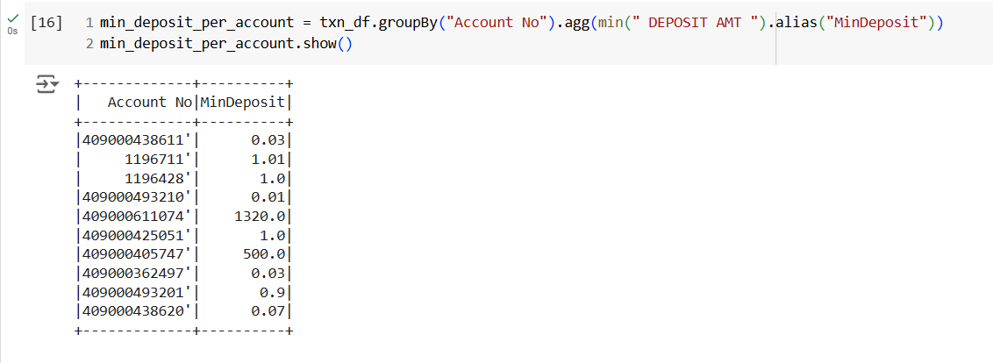**Minimum deposit amount of an account**
2. **Sum of balance in every bank account**

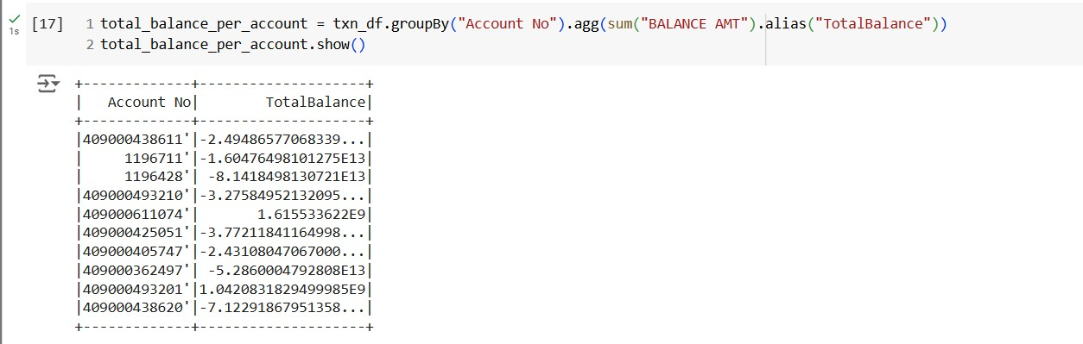

1. 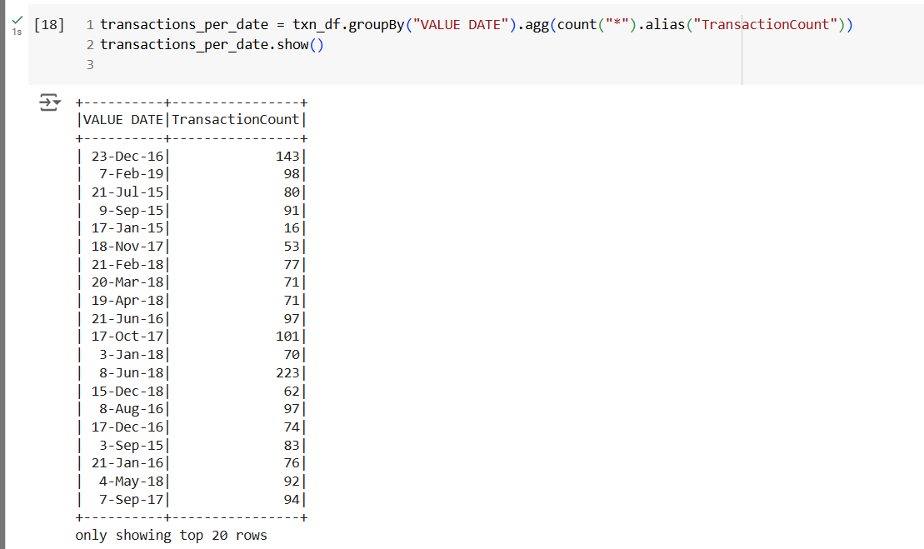**Number of transaction on each date**
2. **List of customers with withdrawal amount of more than 1 lakh**

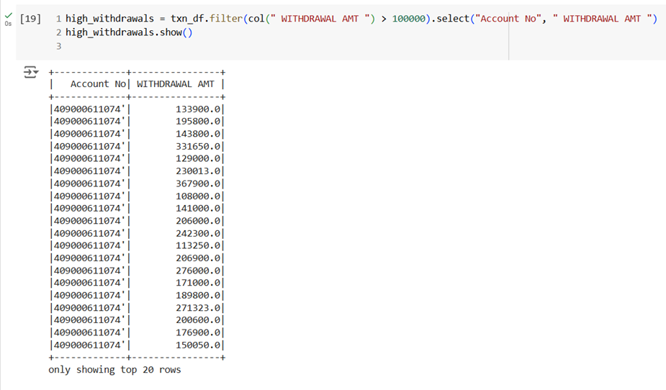

**--Thank You!**